Choosing Your Prosthetist
by J. Michael Wheatley, PhD, CP, BOCOP, CPed, of MHC Orthotics and Prosthetics LLC in Leonardtown, Maryland

As the leader of your rehabilitation team, you should choose the other team members carefully. Choosing the right prosthetist is especially important because you will be working with him or her long after your other therapies have ended.
You should consider several criteria to determine if a specific prosthetist is right for your team.
- How much training and experience does the prosthetist have with your type of amputation?
- Is he or she licensed in your state in the discipline of prosthetics? There are currently nine states that require prosthetists to be licensed, though several states are pending and are expected to pass legislation to require state licensing soon.
- And, just as you would like to know about your surgeon, is the prosthetist board certified?
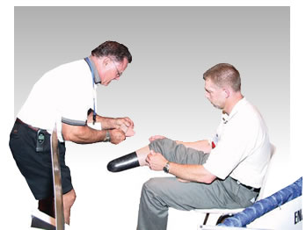There are two independent international certifying agencies that test for competence in the field of prosthetics. One is the American Board for Certification in Orthotics and Prosthetics (ABC). Their board-certified practitioners will bear the identification of Certified Prosthetist (CP) or Certified Prosthetist/Orthotist (CPO). The other is the Board for Orthotist/Prosthetist Certification (BOC). Their board-certified practitioners will bear the identification of BOC Prosthetist (BOCP) or BOC Orthotist/Prosthetist (BOCOP). (See page 27.)
Also, the prosthetic facility should be accredited. This is required by most insurance companies and ensures that the facility has met minimum safety standards to make it amputee friendly. The facility accreditation agencies are ABC, BOC and the Joint Commission on Accreditation of Healthcare Organizations (JCAHO).
It is your life and you deserve the most knowledgeable, experienced and compassionate healthcare professionals on your team. As the leader, you should know your team members and what they are bringing to the table to help you on the road to recovery.

